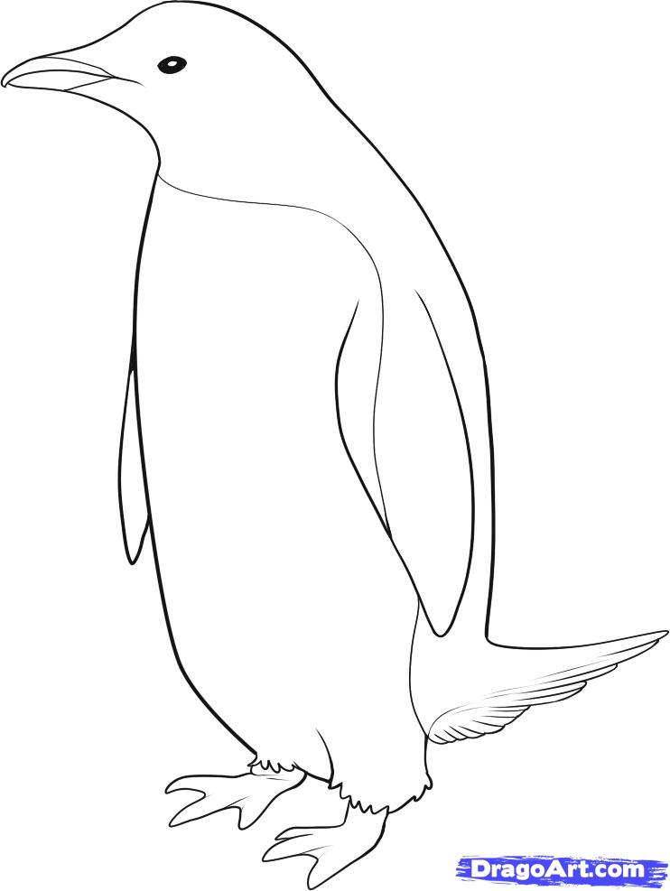

Adélie penguins feed on tiny aquatic creatures, such as shrimp-like krill, but also eat fish and squid. They have been known to dive as deep as 175 meters in search of food, though they usually hunt in far shallower waters less than half that depth. (<http://animals.nationalgeographic.com/animals/birds/adelie-penguin/>)

Waterproof feathers

Webbed feat

**Adélie Penguin**

Short sharp beak

Black and white makes it harder to see when in water.

Short wings reduced to flippers for underwater use