Image from: [www.dragoart.com](http://www.dragoart.com)

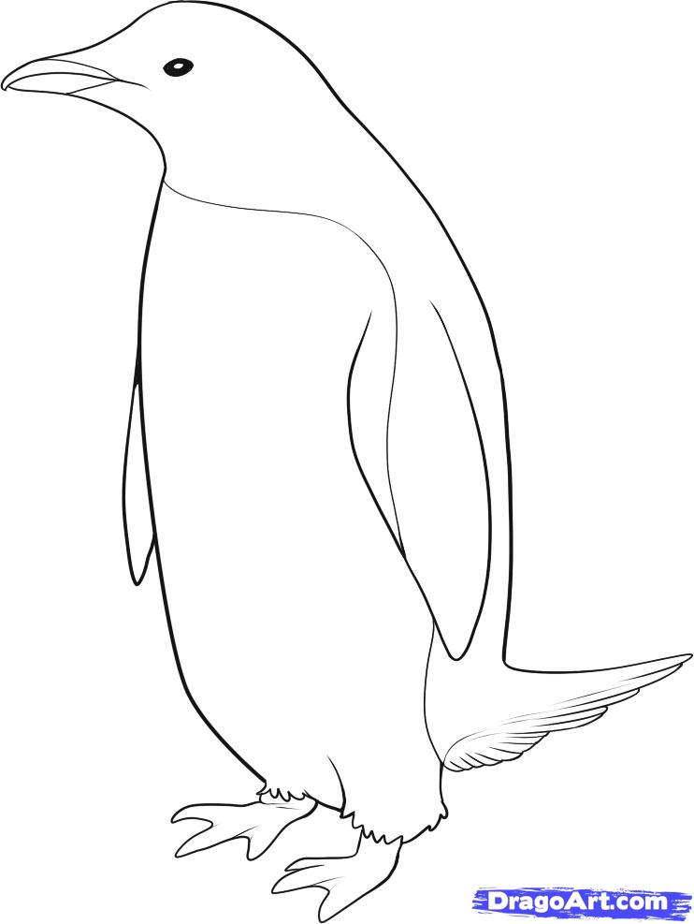

Image from: animal-kid.com



Image from: printablecolouringpages.co.uk

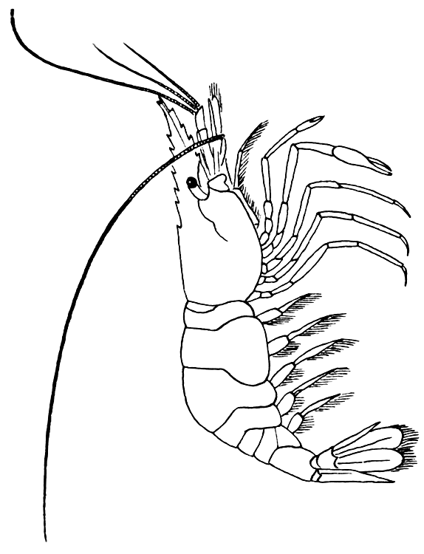

Image from: www.dragoart.com



Image from: cronodon.com

