Name:

**Circle the animals you  
think live in Antarctica**

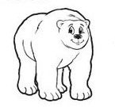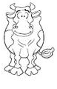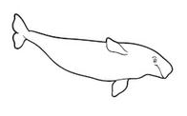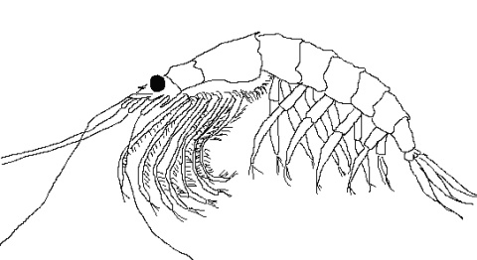 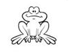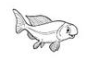 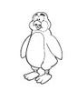 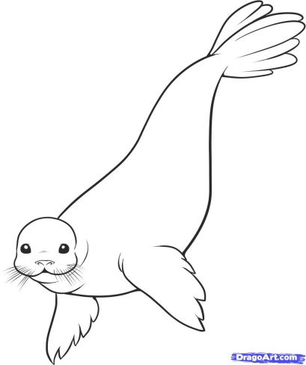 

Pictures taken from:

[depbitundraconnections.wikispaces.com](http://depbitundraconnections.wikispaces.com/Arctic+Extremes+K-2+Lesson+1) [www.dragoart.com](http://www.dragoart.com/tuts/109/1/1/how-to-draw-a-cuddly-seal.htm) [72andrising.com](http://72andrising.com/south-orkney-islands/)

Early finisher: Write next to the Animal you HAVE NOT selected WHY you think they cannot live in the Antarctic. Where do they live?