Name:
Circle the animals you
think live in Antarctica

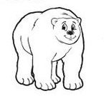
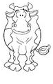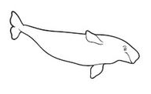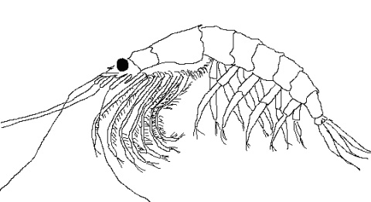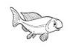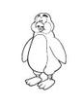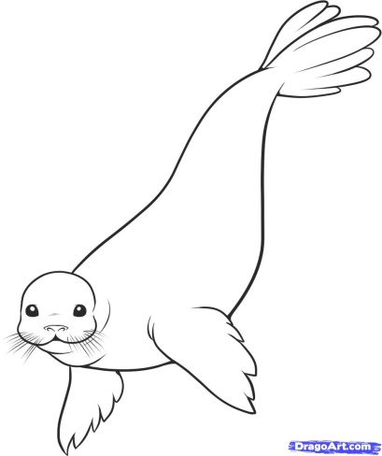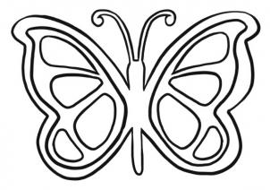

Pictures taken from:
depbitundraconnections.wikispaces.com www.dragoart.com 72andrising.com
Early finisher: Write next to the Animal you HAVE NOT selected WHY you think they cannot live in the Antarctic. Where do they live?

Additional Info:
Whales: “Antarctic whales are any whales which are known to reside near Antarctica for at least part of the year. This includes: Arnoux's beaked whale, Blue whale, Dwarf sperm whale, Fin whale, Gray's beaked whale, Humpback whale, Minke whale, Antarctic minke whale, Pygmy right whale, Pygmy sperm whale, Sei whale, Southern bottlenose whale, Southern right whale, Sperm whale and Strap-toothed whale.”
http://en.wikipedia.org/wiki/Antarctic_whales
Seals: “Although there are 35 species of seals, only six types live in Antarctica: Antarctic Fur Seals, Crabeater Seals, Leopard Seals, Ross Seals, and Weddell Seals. However, these six species make up the majority of the world's seal population.”
http://lrs.ed.uiuc.edu/students/downey/project/seals.html
Krill: “Antarctic krill, Euphausia superba, is a species of krill found in the Antarctic waters of the Southern Ocean. It is a small, swimming crustacean that lives in large schools, called swarms, sometimes reaching densities of 10,000–30,000 individual animals per cubic metre.”
http://en.wikipedia.org/wiki/Antarctic_krill
Fish: There are only a few types of Antarctic fish, all well-adapted to the cold. More are continually being discovered
.
Penguins: “There are just 17 species of penguin worldwide. Of this 17, there are 4 that live and nest on and around the Antarctic continent and a further 3 that live and nest on Antarctic and sub-Antarctic islands, giving us 7 species that can be considered "Antarctic Penguins".
http://www.coolantarctica.com/Antarctica%20fact%20file/wildlife/antarctic_penguins.htm

