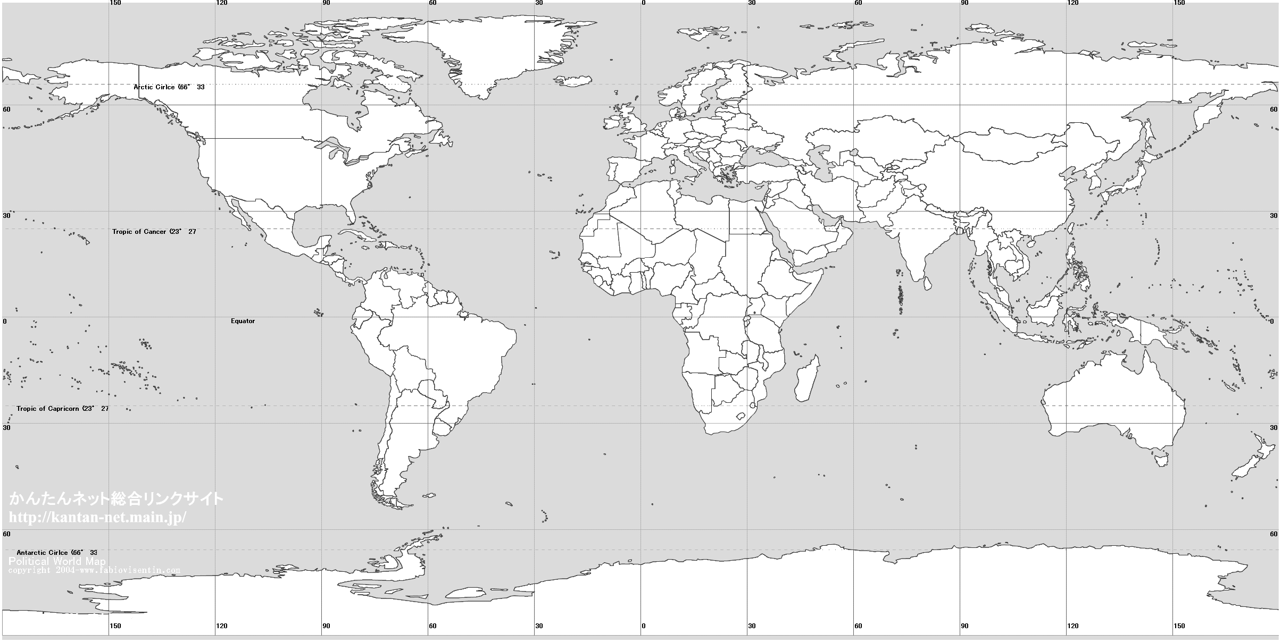

**11578.3 km**

**11160.2 km**

**14348.1 km**

**4525.74 km**

**13125.5 km**

**1299.70 km**

**7473.85 km**

**12817.5 km**

**4573.14 km**

**3020.48 km**