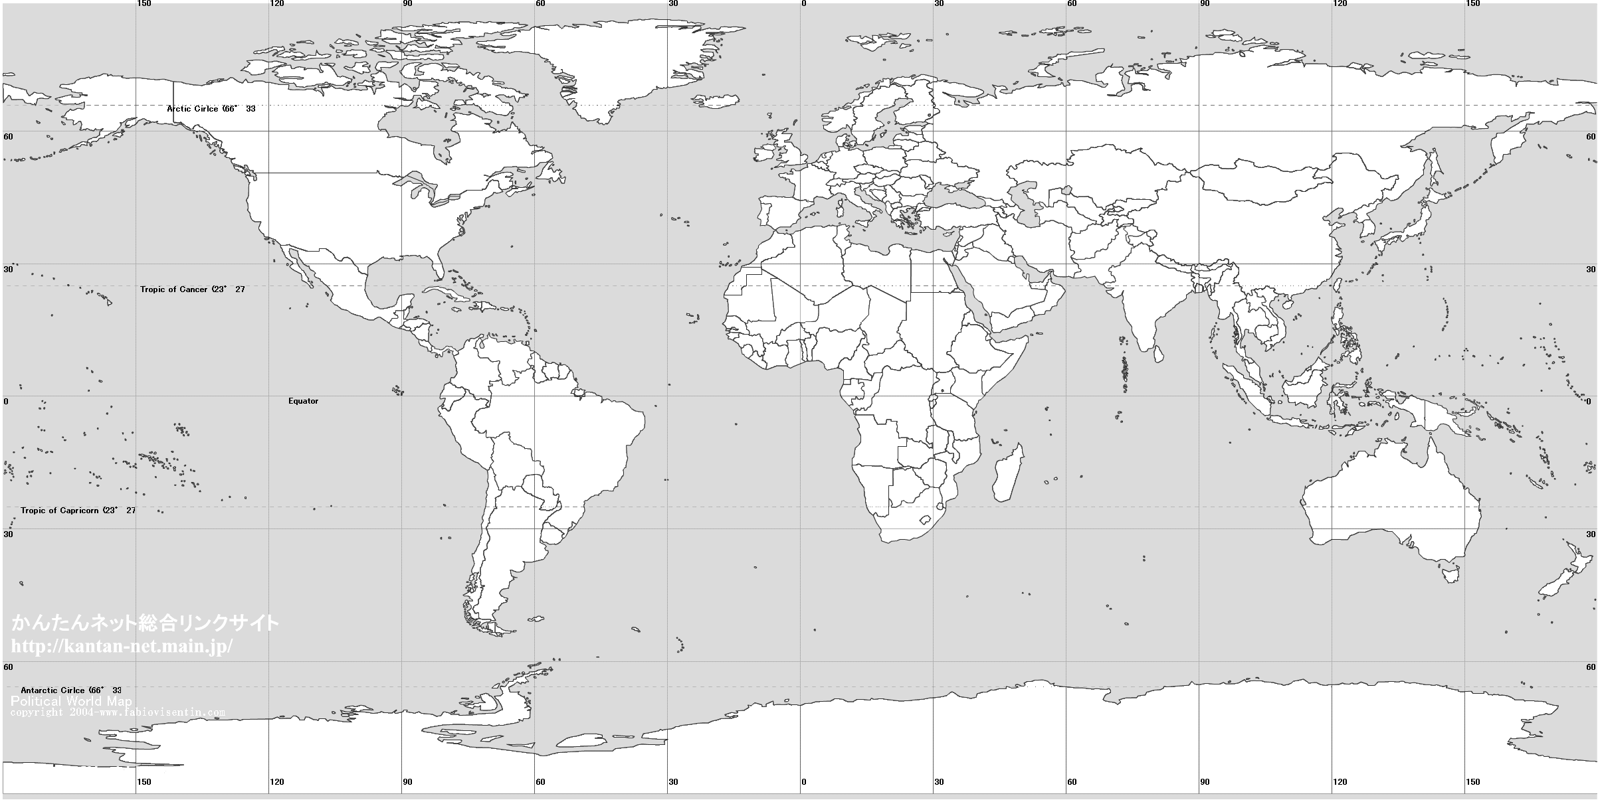
Image from: www.antidoping.hk

SCALE:
30 latitude (one square)= 3,300 km (roughly)

