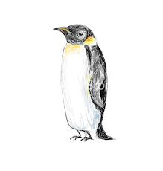

My home in Antarctica is like nowhere else. It is located at the bottom of the world; you can find it by going south. It is very cold and is covered in snow and ice. It is very quiet, with very few animals or humans around. Sometimes it can feel very empty. We are separated by the rest of the world by the Southern Ocean. The Ocean sometimes freezes over, creating sea ice. There are some large mountains but most are covered by an Ice Sheet......

**EXAMPLE ANSWER**

**My home, Anatarctica  
Why other peguins should join**