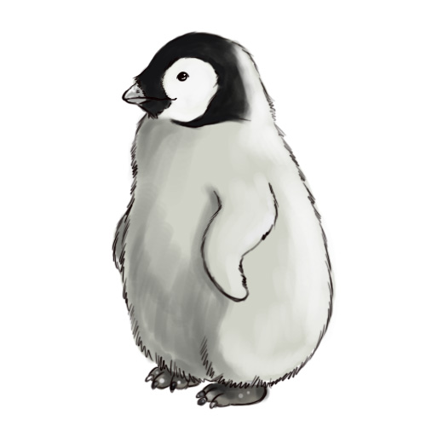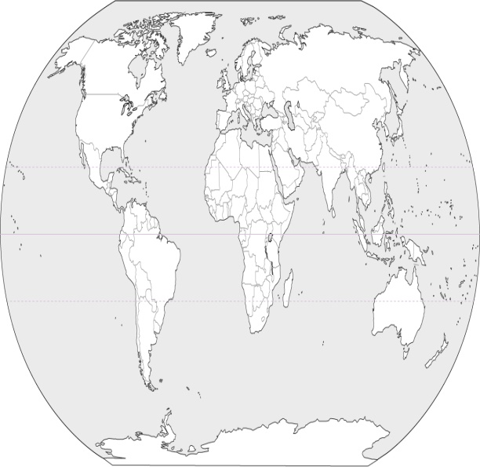

Image from:

www.wikihow.com

About me:

Mr. Knott

Age: 25

A teacher and Antarctic scientist

Adélie Penguin

# The effects of Antarctic tourism

Template made by Mr. Knott  
[mrknottteacher@gmail.com](mailto:mrknottteacher@gmail.com)

### The purpose of this Phamplet



This pamphlet is designed to inform the public about animals in Antarctica. It discusses the animal’s habitat, how it manages to live in that habitat, the type of tourism it might encounter and guidelines to avoid impacts to this animal.



picture of eiffel tower

## Where is Antarctica?

“Antarctica is Earth's southernmost continent, containing the geographic South Pole. It i situated in the Antarctic region of the Southern Hemisphere, almost entirely south of the Antarctic Circle, and is surrounded by the Southern Ocean.

Antarctica, on average, is the coldest, driest, and windiest continent, and has the highest average elevation of all the continents.”

en.wikipedia.org/wiki/**Antarctica**

Created by:

Mr. Knott

## Tourist impacts to the **animals’** habitat

Change in food source: With an increase of ships you have the possibility of more damage to marine environments leading to more damage to the ecosystem. Noise and disturbance around popular tourist destinations (as most ships go to penguin colonies), could cause migration of penguins food sources, causing starvation or penguin migration.

Illness: Spill of waste, pollution and oil from disasters could cause the penguins to get ill even leading to death, or waste left by tourists.

Forced change in movement patterns: Changes to the penguin tracks, from ground disturbance.

Physical disturbance: from interaction with the animals, creating fear or change of routines. This could (and some say has) caused decrease in breeding.

## **Animals’** habitat

Sea & Sea Ice

Penguins hunt in the seas, they get into the sea through cracks in the sea ice. The sea is cold, but can vary in temperatures (more information about the sea and sea ice).

rocky areas

Penguins generally live in the rocky areas. This is generally where penguins breed. Rocky areas can be....

## How is the **animal** suited for its habitat?

They have dense double layer of feathers and a large fat reserve.

While other birds have wings for flying, penguins have flippers to help them swim in the water.

Penguin’s black and white plumage serves as camouflage while swimming.

They also huddling together for warmth to prevent heat loss.

Penguins can drink sea water.

## Strategies to avoid impacts

“Walk slowly, occasionally stopping to give wildlife the time and space they need.

As a general principle, keep noise to a minimum and avoid approaching birds and animals any closer than 5 meters / 15 feet; in some instances even this may be too close, so watch the birds’ and animals’ behaviour as you approach and stop, or retreat, if they show signs of disturbance.

Be aware of your location relative to your fellow visitors – making sure you do not surround animals or cut off their route to the sea.

Heed the advice of your guides; they want you to gain as much as possible from your experience while treading softly on this unique environment.”

[www.iaato.org](http://www.iaato.org) - Guidance for Visitors to the Antarctic