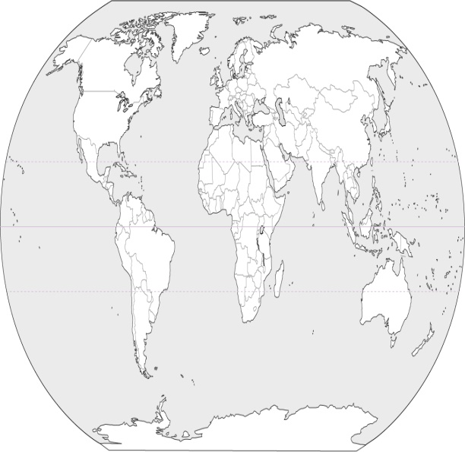

About me:

# The effects of Antarctic tourism

Template made by Mr. Knott  
[mrknottteacher@gmail.com](mailto:mrknottteacher@gmail.com)

### The purpose of this Phamplet





picture of eiffel tower

## Where is Antarctica?

Created by:

## Strategies to avoid impacts

## Tourist impacts to the habitat

.

## habitat

## How is the suited for its habitat?