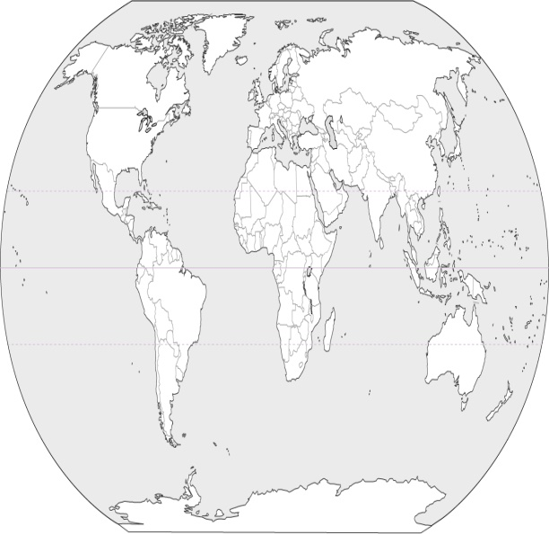

About the student:

Picture?

Age?

School?

Interests?

Animal’s name

# The effects of Antarctic tourism

Template made by Mr. Knott  
[mrknottteacher@gmail.com](mailto:mrknottteacher@gmail.com)

### The purpose of this Phamplet



What do you want this pamphlet to achieve?

Who?

What?

Why?

How?



picture of eiffel tower

## Where is Antarctica?

Students write a little about Antarctica.

Possible points:

* Antarctica’s location
* Why is it different from the rest of the world?
* How far away is it?
* What animals live there?
* Who goes down there?

Created by:

Student’s name

## Tourist impacts to the **animals’** habitat

Students list how tourism could affect the environment around the animals.

Information can be found from the PPT or from the ‘Environmental aspect” doc, or from student’s own research.

## **Animals’** habitat

### type of habitat

Students write a description of the habitat.

## How is the **animal** suited for its habitat?

Students write features of the animal that make it suitable for its environment.

## Strategies to avoid impacts

Students find or create strategies to avoid tourism impacts.