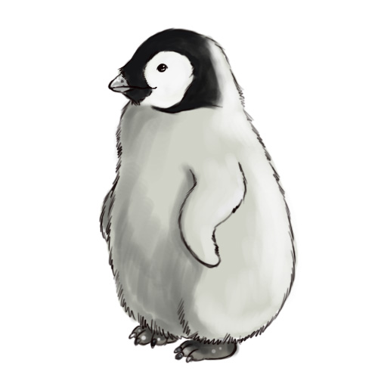

**Walk slowly**

**Adélie Penguin**

**Take everything away with you**

**Keep noise   
to a minimum**

**Do not surround me**

**Keep atleast  
5 meters  
distance**

**Look out for me,   
give me space**

Image from:

www.wikihow.com